Microsoft Office User

Trainsion Document FOR COLOMBIA

Table of Contents

Hadoop Architecture @Colombia 3

Hadoop Eco system Component Layout 4

WebAddress: 6

Architecture: 6

Starting/Stopping Cloudera Manager : 6

Hue 11

WebAddress 11

Architecture: 12

Hue Interfaces for Developers: 13

Logs Hadoop components: 14

Through Cloudera Manager: 14

From Hadoop Servers 15

## Hadoop Architecture @ Colombia

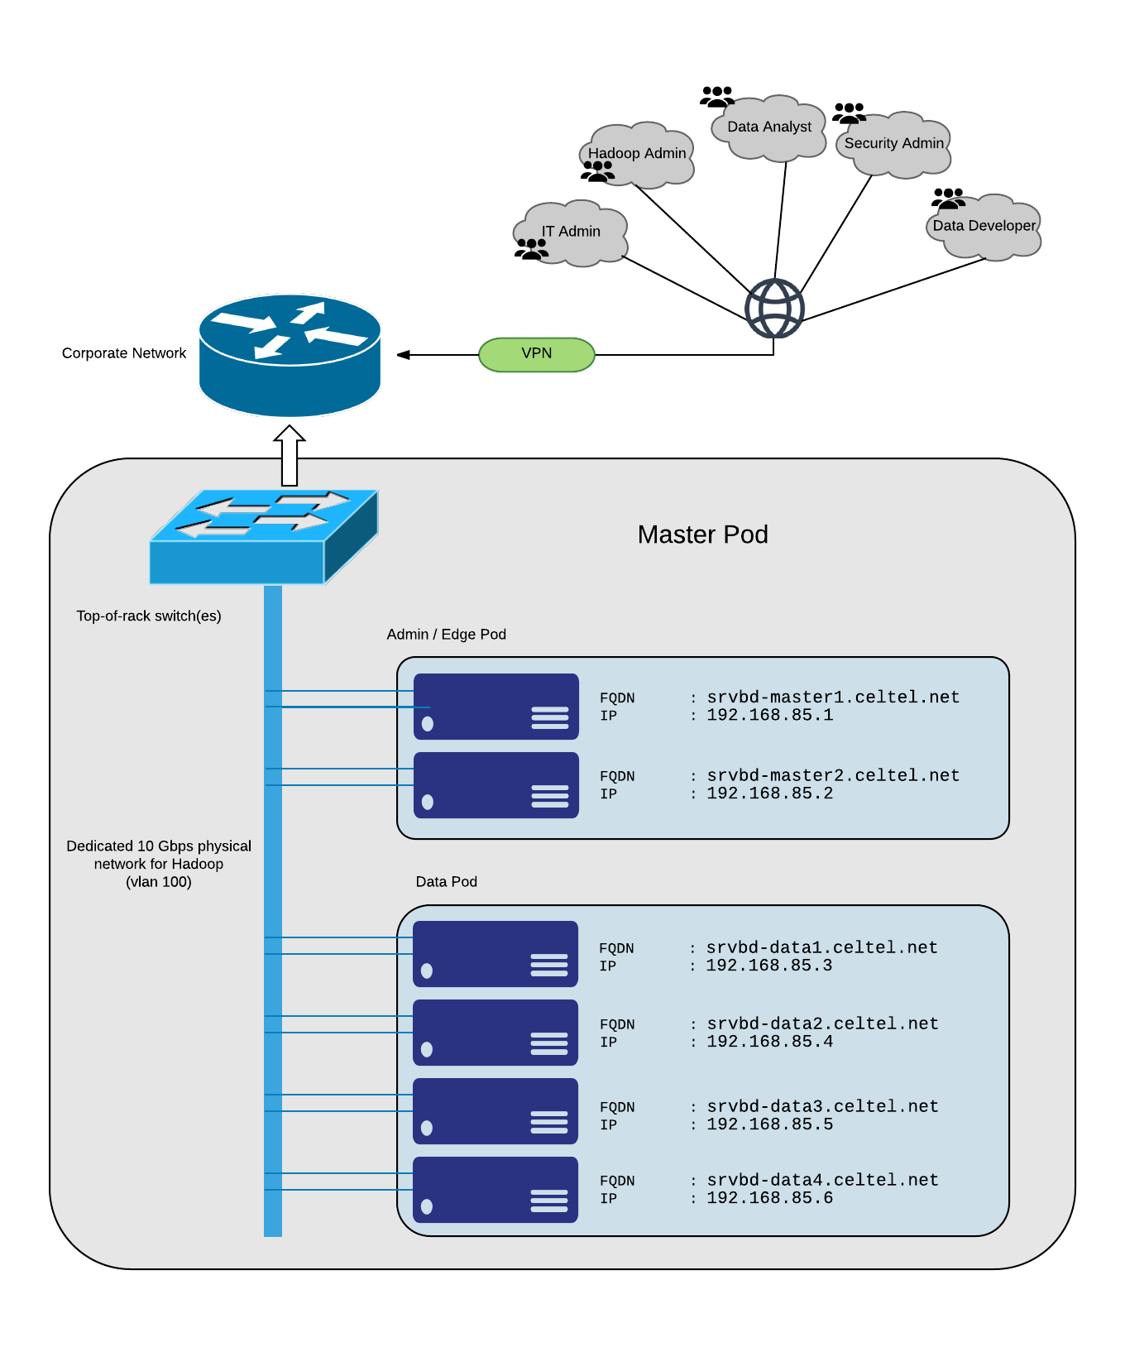

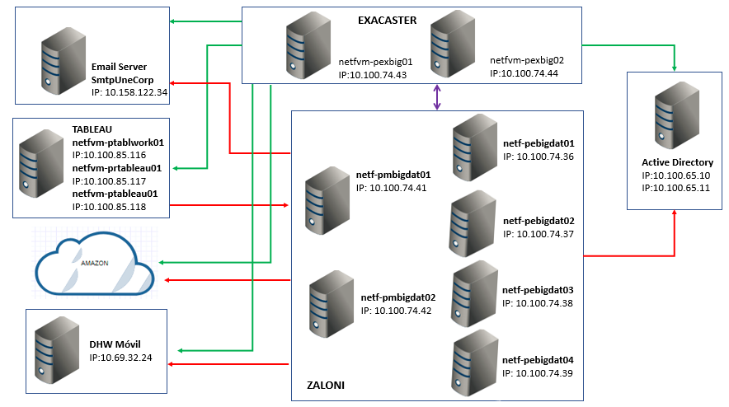

## Hadoop Eco system Component Layout

Component layout can be accessed through cloudera manager as below ( please note image below is a generic image , the hostnames for the HN cluster will be shown properly on CM web page) :

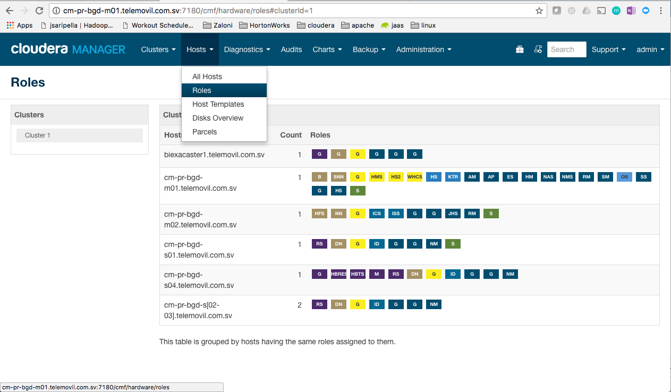

Below are layout of components on individual nodes, hovering over the components provides the information of service .

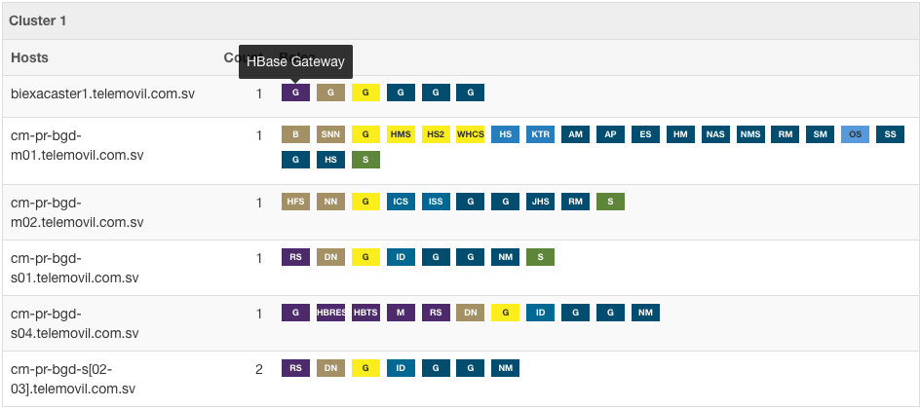

Cloudera Manager

### WebAddress:

<http://10.100.74.41:7180/>

### Architecture:

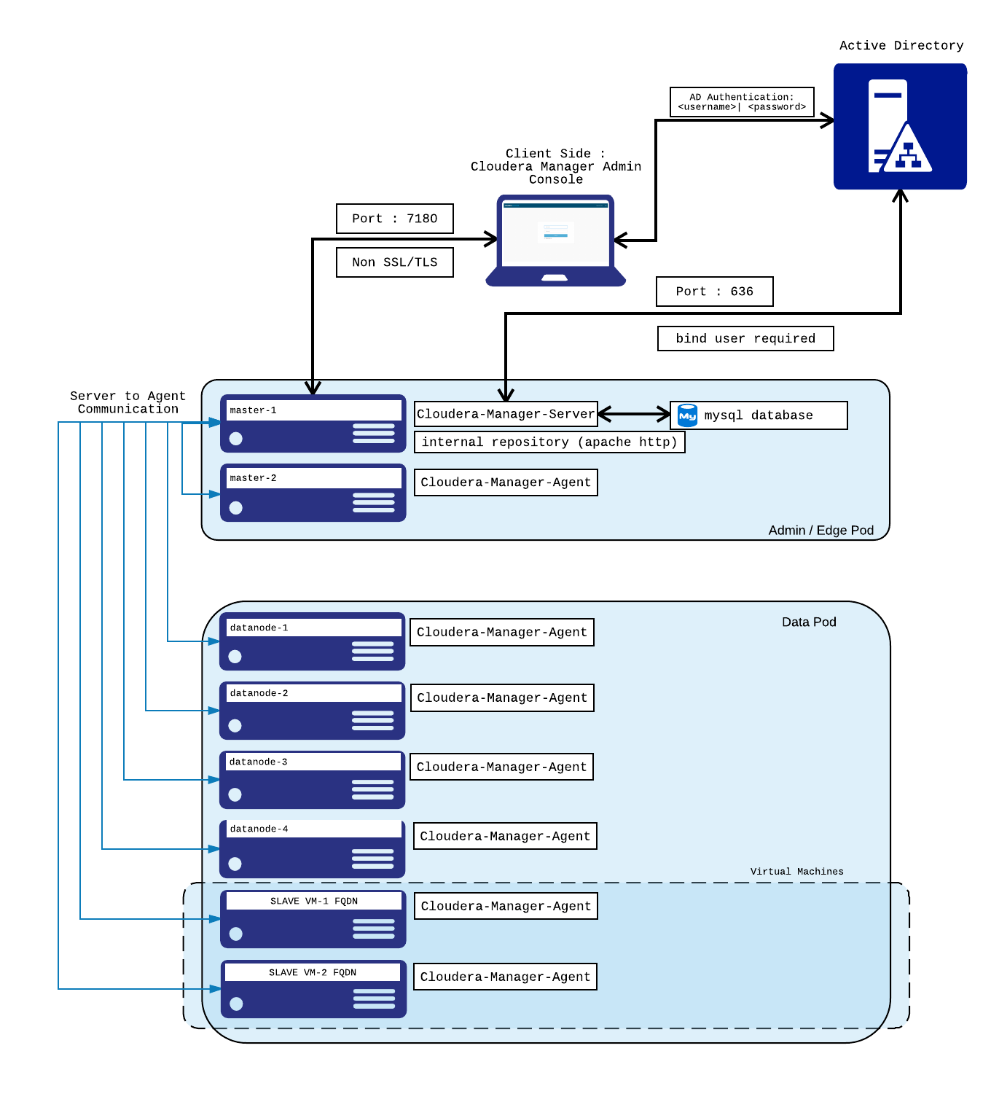

### Starting/Stopping Cloudera Manager :

Server:

On srvbd-master1.celtel.net:

Checking status:

> service cloudera-scm-server status

stopping cloudera manager server:

> service cloudera-scm-server stop

starting cloudera manager server

> service cloudera-scm-server start

Agents:

On master & slave nodes

Checking status:

> service cloudera-scm-agent status

stopping cloudera manager server:

> service cloudera-scm-agent stop

starting cloudera manager server

> service cloudera-scm-agent start

Logs for cloudera manager

Cloudera-Manager Server

/var/log/cloudera-scm-server/

Cloudera-Manager Agent

/var/log/cloudera-scm-agent/

Cloudera Manager admin login credentials :

Username : admin

Password : password shared with Sandra

Admin Group on AD for Cloudera Manager : dlg-cm-admin

Various Services monitored by Cloudera Manager

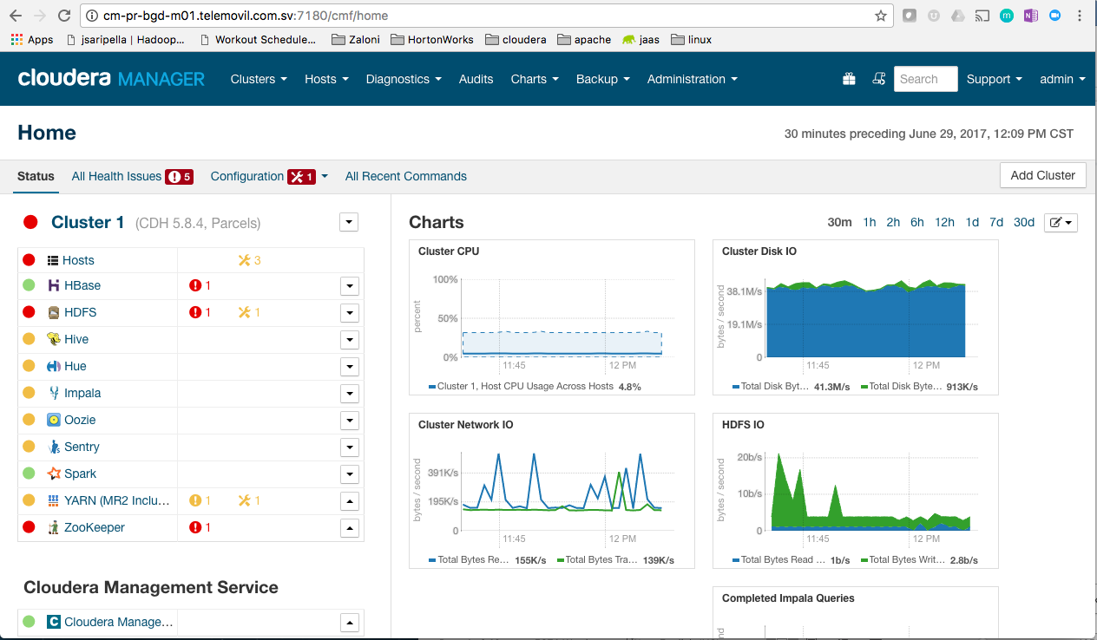

Starting and Stopping services through Cloudera Manager

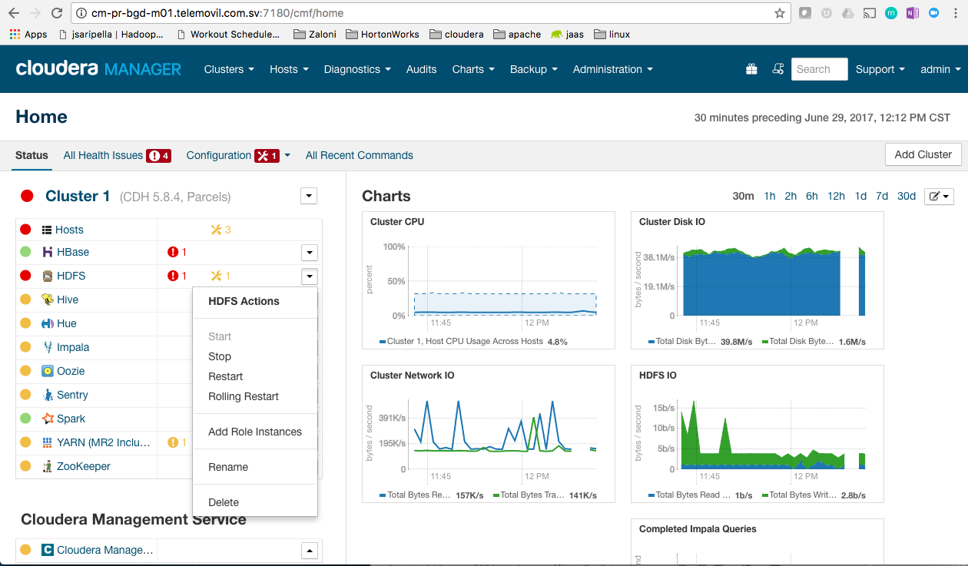

Clicking on individual service provides more details about the service :

Hosts participating in this service( please note hostname on CM will be specific to HN cluster)

Instances

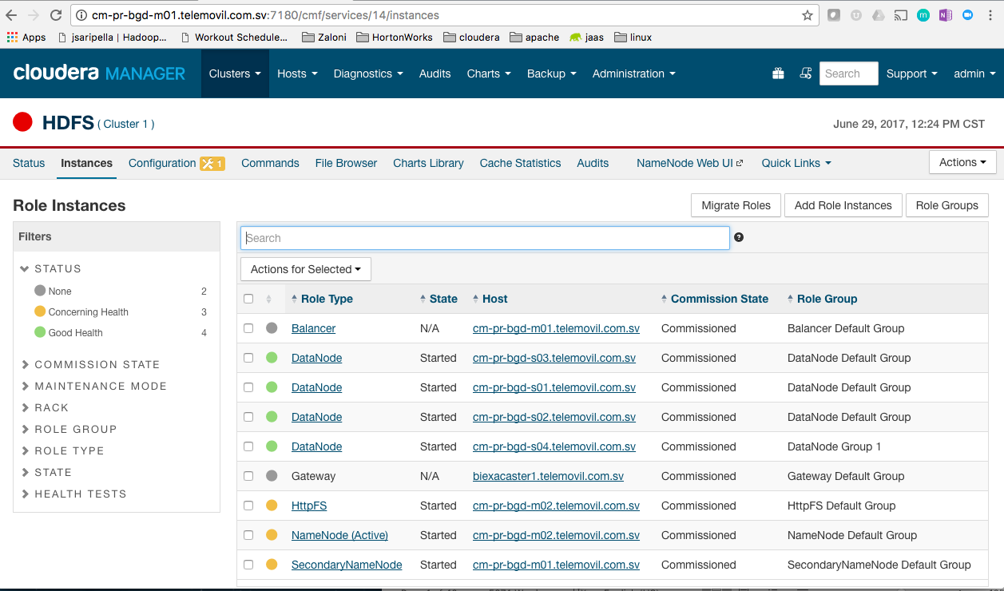

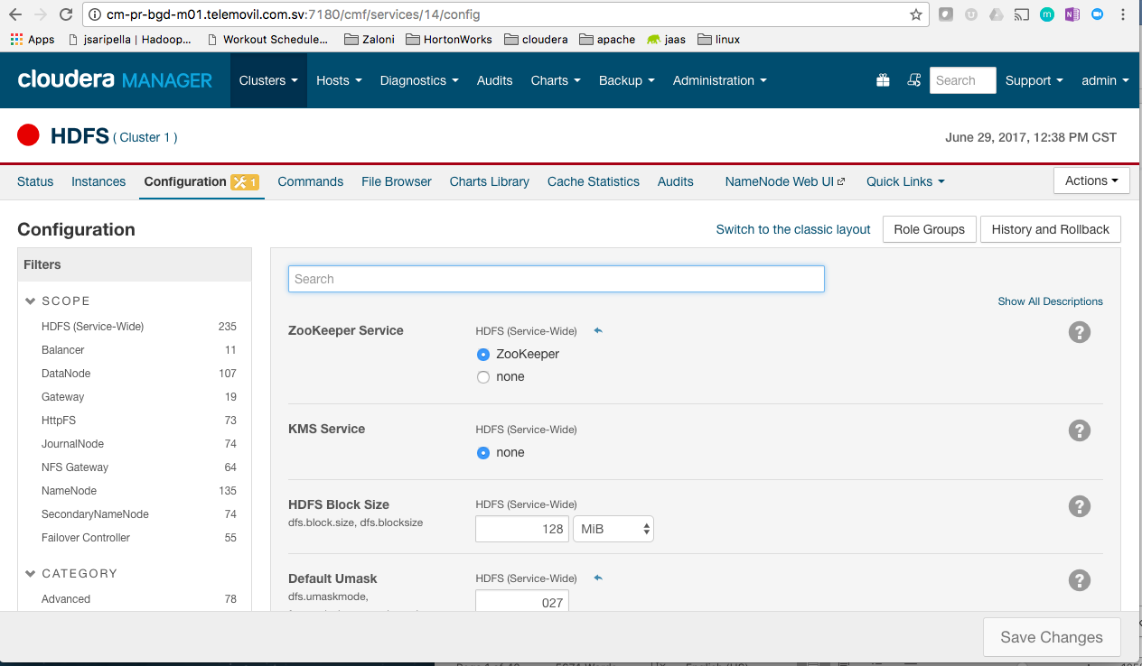

Configurations

## Hue

### WebAddress

http://10.100.74.41:8888

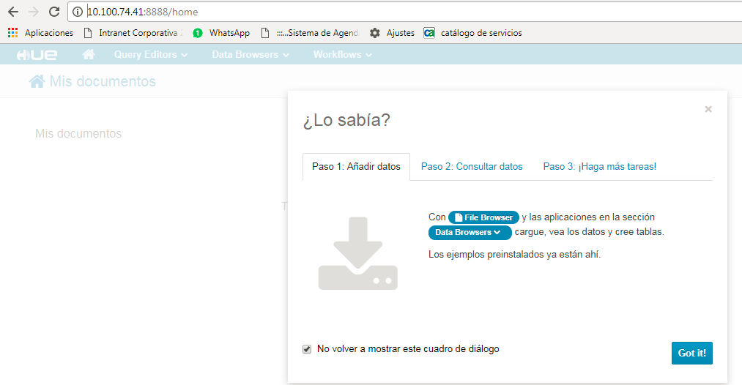

Any user on can login into Hue using there AD credentials

### Architecture:

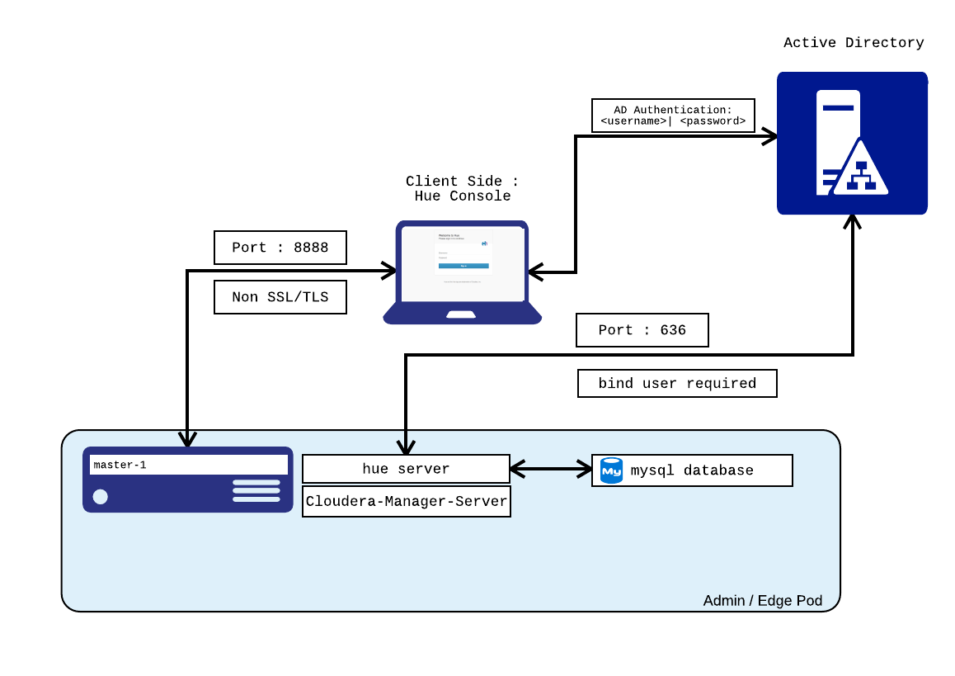

### Hue Interfaces for Developers:

Hive,Impala,pig etc.. oher services can be accessed as shown in the below Hue interface.

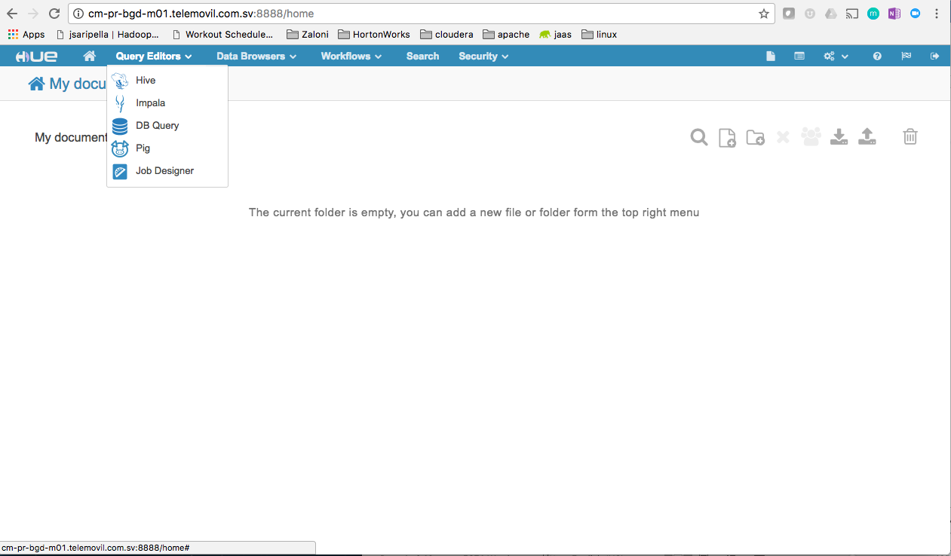

## Logs Hadoop components:

Logs for individual services can be accessed two ways :

* Through Cloudera Manager
* From Hadoop Servers

### Through Cloudera Manager:

Below is an example to access logs for a service :

To get logs for Namenode , One has to access the namenode service from cloudera manager as shown below :

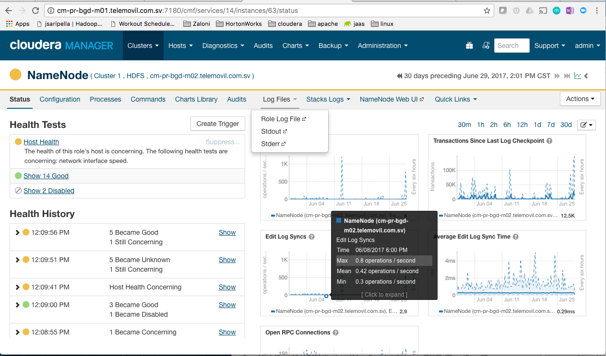

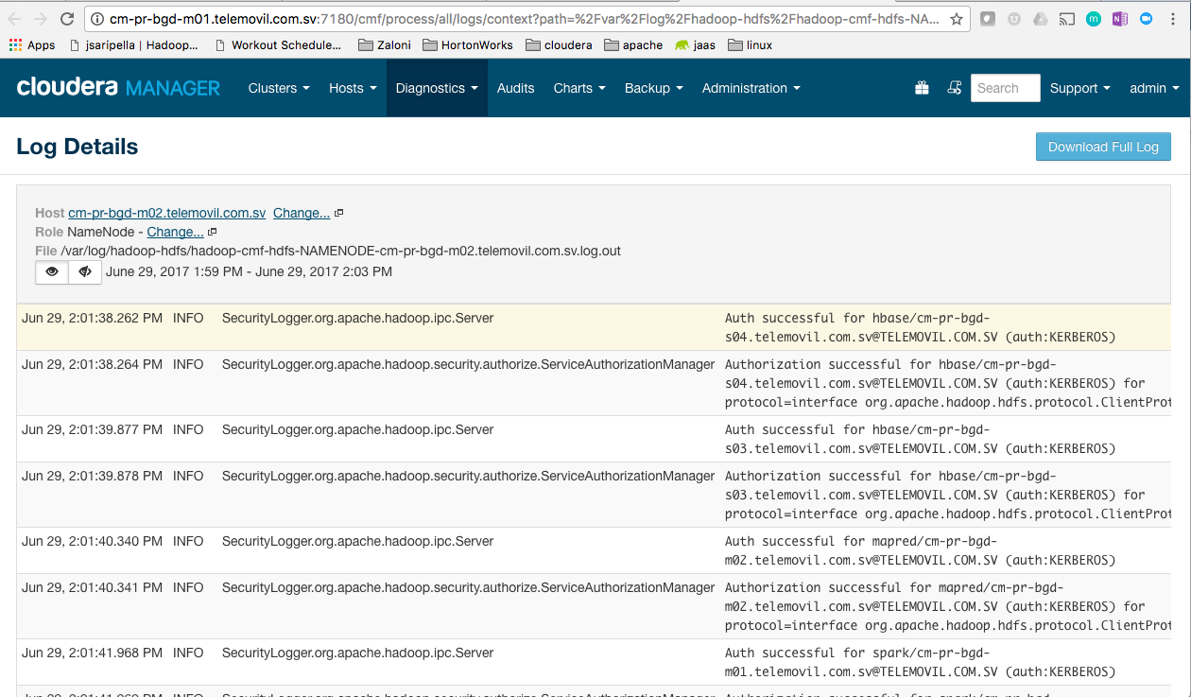

### From Hadoop Servers

The same log for namenode can be found on the host where namenode is running , and log location :

/var/log/hadoop-hdfs/hadoop-cmf-hdfs-NAMENODE-cm-pr-bgd-m02.telemovil.com.sv.log.out

The above information can be gathered from cloudera manager :



Below is the information for log locations for individual services

/var/log/catalogd

/var/log/cloudera-scm-alertpublisher

/var/log/cloudera-scm-eventserver

/var/log/cloudera-scm-firehose

/var/log/cloudera-scm-headlamp

/var/log/cloudera-scm-navigator

/var/log/hadoop-hdfs

/var/log/hadoop-httpfs

/var/log/hadoop-mapreduce

/var/log/hadoop-yarn

/var/log/hbase

/var/log/hcatalog

/var/log/hive

/var/log/hue

/var/log/hue-httpd

/var/log/impala-llama

/var/log/impalad

/var/log/oozie

/var/log/sentry

/var/log/solr

/var/log/spark

/var/log/sqoop2

/var/log/statestore

/var/log/zookeeper